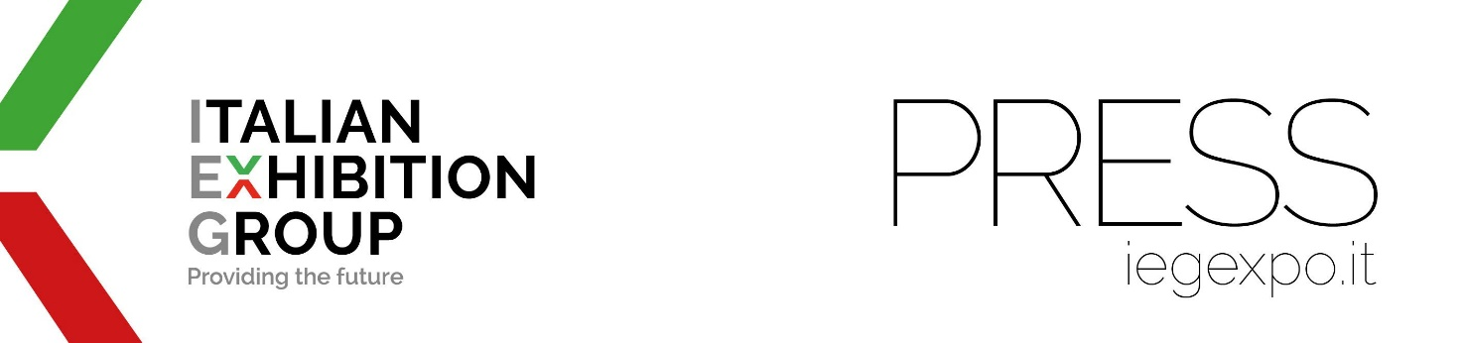

press release
(English translation)

Italian Exhibition Group receives the UFI Digital Innovation Award 2025

- UFI, the exhibition industry’s global association with 900 members worldwide, has awarded IEG the prestigious recognition
- IEG CEO, Corrado Peraboni, “This achievement strengthens our determination to create increasingly smart and connected experiences for our customers and stakeholders”
- The award ceremony in Hong Kong in November

Rimini (Italy), 17th June 2025 - Italian Exhibition Group (IEG) has won the UFI Digital Innovation Award 2025, the prestigious international award promoted by UFI - The Global Association of the Exhibition Industry, which boasts 900 members from the exhibition system worldwide.
Every year, UFI awards the most innovative projects in the global exhibition industry, from human resources to digital innovation, marketing and sustainable development.

In the "Digital Innovation" category, the theme for the 2025 Award was "Driving Change through Digital Innovation."
The aim of the topic was to identify innovative strategies that demonstrate how companies can use technology to make a measurable impact on the performance of a trade show or organization: and Italian Exhibition Group clinched the award with its "All-in-one Ecosystem" nomination.

“Winning the UFI Digital Innovation Award significantly acknowledges Italian Exhibition Group's commitment to serving our communities,” explained IEG CEO, Corrado Peraboni. "This achievement strengthens our determination to create increasingly smart and connected experiences for our customers and stakeholders, in line with our mission: to be a Community Catalyst.”

The integrated technology ecosystem, developed by IEG's Innovation area headed by Simone Zaccherini, was thus evaluated as the most advanced proposal due to its ability to radically transform the trade show experience by using artificial intelligence, automation and unified data management. The core objective of the system is to simplify interaction between exhibitors, visitors and organizers: from registration to post-event content usage through a new mobile app and an omnichannel platform that ensures continuity of experience across all touchpoints. The adoption of AI also enables user itinerary personalization and improved engagement and service effectiveness, with a significant impact on exhibition performance.

Winners of UFI Awards 2025 will be officially honored at the 92nd UFI Global Congress this November in Hong Kong SAR.

PRESS CONTACT ITALIAN EXHIBITION GROUP
international press office coordinator: Silvia Giorgi; media@iegexpo.it
Cesare Trevisani, media consultant, “Smart Comunicazione” ctrevisani@smartcomunicazione.it

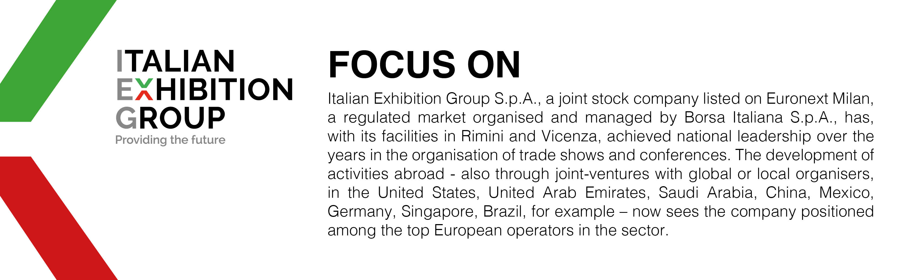

This press release contains forecast elements and estimates that reflect the management’s current opinions (“forward-looking statements”), particularly regarding future management performance, realization of investments, cash flow trends and the evolution of the financial structure. For their very nature, forward-looking statements have a component of risk and uncertainty, as they depend on the occurrence of future events. The effective results may differ (even significantly) from those announced, due to numerous factors, including, only by way of example: food service market and tourist flow trends in Italy, gold and jewellery market trends, green economy market trends; the evolution of raw material prices; general macroeconomic conditions; geopolitical factors and evolutions in the legislative framework. Moreover, the information contained in this release does not claim to be complete, and has not been verified by independent third parties. Forecasts, estimates and objectives contained herein are based on the information available to the Company as at the date of this release.

